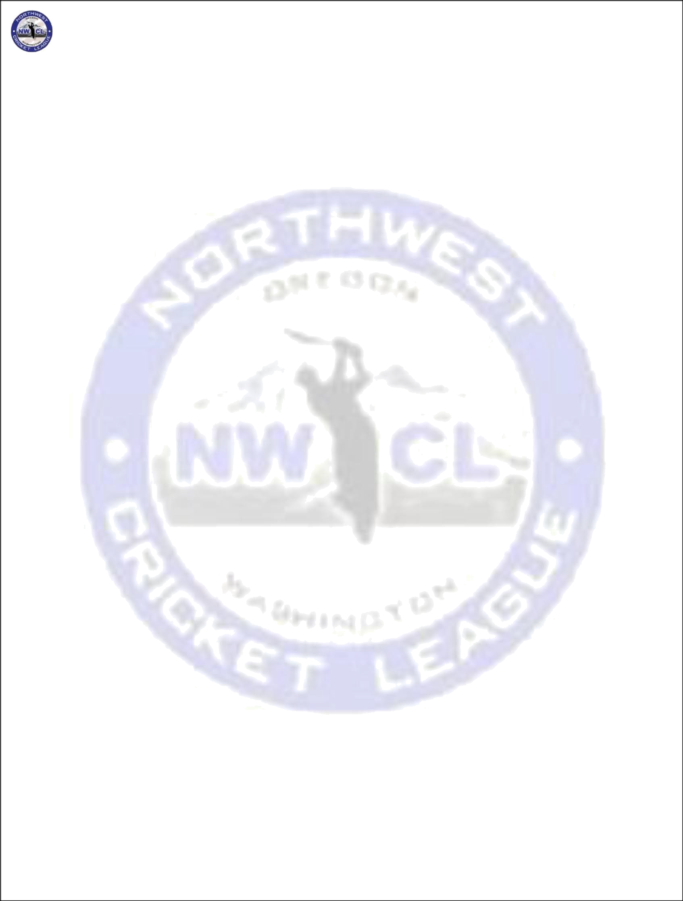
NORTHWEST CRICKET LEAGUE – PLAYING LAWS

Contents
- Laws of Cricket 2
- Field 2
- Players 3
- Substitutes 3
- Umpires and Certification 4
- Captains 5
- Scoring 5
- Balls 5
- Innings 6
- Practice on the pitch 6
- ICC ODI rules Adopted by the NWCL 6
- Start of Play 7
- Intervals 7
- Interruptions of play 8
- Result 8
- Wide and No-Ball 9
- Protective Equipment 10
- The wicket is down 10
- Criteria for Cancellation of Matches due to Weather 10
- Determination of the Standings in the league table 11
- Interpretations 11
- Scheduling 11

Page 1 of 12

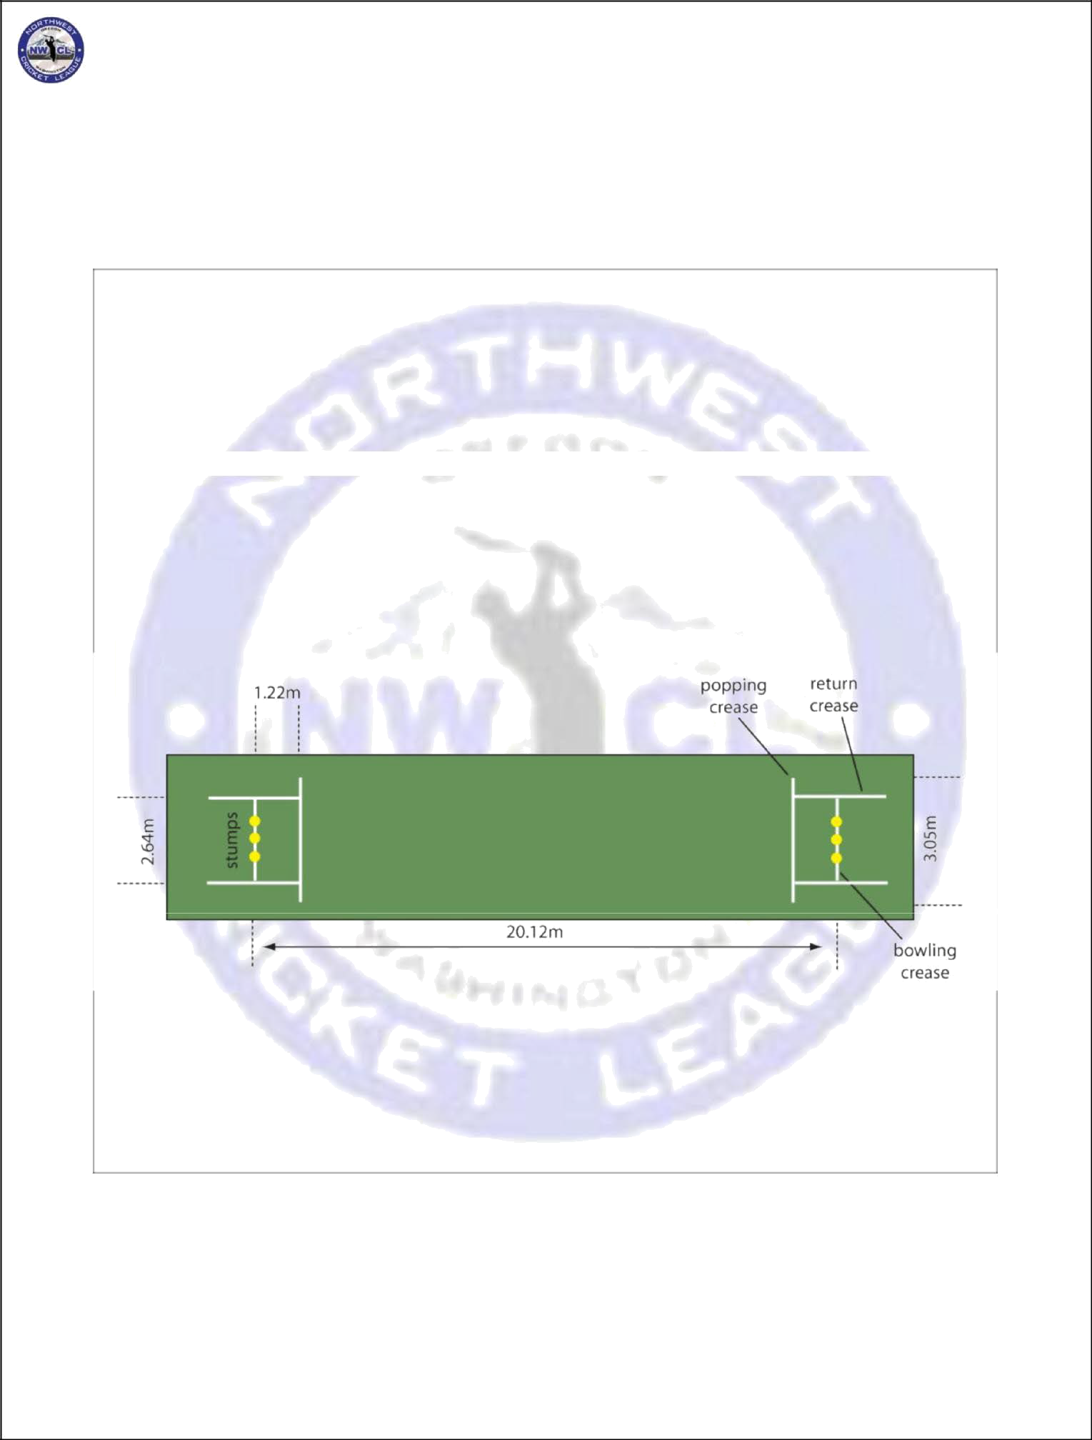
NORTHWEST CRICKET LEAGUE – PLAYING LAWS

Laws of Cricket
The Laws of Cricket - 2000 Code 4th Edition - 2010, published by the MCC, will be followed for all NWCL matches, except as noted in the ensuing paragraphs. All member clubs are always strongly urged to have one or more copies of the Laws handy.

Field
  - As required by the Laws of Cricket, the Umpires are required to check the creases, wickets and other implements of the game before the toss for innings. If the umpires find even one of
the creases either not marked, or improperly marked, or the wickets improperly pitched, one penalty point will be deducted from the home team for that match.

  - IF requested by the umpires, the Home Team for a match shall provide a tape measure or equivalent distance measuring device to aid the umpires in determining whether the creases and boundaries are properly marked.

  - Two off-side "wide-marker lines", 1 foot in length, will be drawn perpendicular to the Bowling crease, towards the Popping crease, 29.5 inches from the edge of each outer stump. One of these lines is for a right-handed batsman and the other for a left-handed batsman.

  - Two semi-circles shall be drawn on the field of play. The semi-circles shall have as their center the middle stump at either end of the pitch. The radius of each of the semi -circles shall be 30 yards (27.43 meters). The semi-circles shall be linked by two parallel straight lines drawn on the field. The fielding restriction areas should be marked by continuous painted white lines or 'dots' or cones at 5-yard (4.57 meters) intervals.
  - The Home Team is responsible for providing a suitable wicket on which to play cricket. This may take the form of a mat, a Flex pitch or artificial turf. If a grass wicket is to be used for league games, then it must receive an official assessment by the NWCL Management or a person they appoint for this purpose.
  - The ground must be ready and all markings in place and correct 15 minutes before the start of Play.
  - Every home team is required to have a functional and visible scoreboard on the field. The

Page 2 of 12

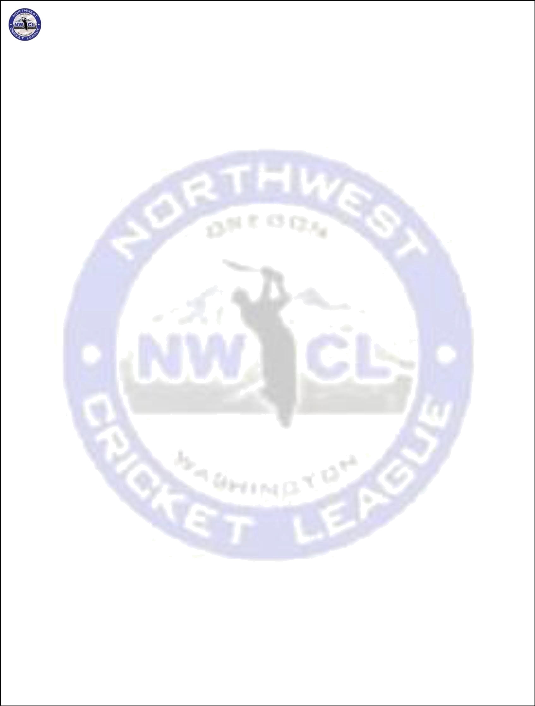
NORTHWEST CRICKET LEAGUE – PLAYING LAWS

Scoreboard's letters/digits must be no smaller than 5"x8". Failure to provide a scoreboard shall result a monetary fine of $50 to the home team.
  - TOSS: Umpire must be at the field of play, ready for a toss between 30 and 15 minutes before the scheduled start of play. If there is no umpire, the toss cannot take place & this may delay the start of play. However, NWCL Team captains together, may choose to toss & begin the match with stand-in umpires of their choice & report the late umpires. Once made, the winning captain shall notify his counterpart of his decision to bat or bowl immediately, once notified, the decision cannot be changed. If he does not adhere to this rule, the other Captain shall be deemed to have won the toss by default & must immediately decide whether to bat or bowl & inform all

NOTE: All fines must be paid within 2 weeks of the first violation. If the fine is not paid on time, the team will forfeit their next game

Players
  - A match shall be played with a minimum of 8 players from each club, except for matches in which the away teams must travel more than 100 miles to get to the game. A minimum of 7 players from each club is required for the club playing 'away', in matches in which one of the teams must travel more than 100 miles to get to the game.
  - Toss to be forfeited by the team who has less than 8 players at the time of toss (10mins before the game start time) or whenever the umpire calls for it. Passed in Feb 2015.
  - A club/team shall register a new player no later than the following Monday of the weekend he plays.
  - The following are the criteria for Player to be eligible for participating in the play
-offs: NWCL Membership/Registration
2 Regular Season Games with the team player is representing in Playoffs (Passed at BOD on 05/15/2014)
Other NWCL eligibility criteria

  - PLAYER PROFILES: (passed at Extra BOD on 11/19/2016)

Every player (new/old) must update his profile on cricclubs.com/NWCL website with his recent picture and legal Name having clear face identity. A player without a profile picture on the website will not be allowed to participate in a game if an objection is raised to the umpire by any of the opposing team players on the game day.

Exception to the Rule: If the player is listed on the roster, but, does not have his picture updated, the umpire can check his ID and, can allow the player in question, to play the game. Umpire must verify the new player’s id and make sure the score card is updated correctly after the game and inform the management.

Substitutes
  - If one club (X) has less than 11 players nominated for a match, the captain of this club (X) can request the opposing Captain to allow substitute fielders to make 11.
  - The opposing Captain cannot refuse this request, unless the substitute fielders requested are members of his club.

Page 3 of 12

NORTHWEST CRICKET LEAGUE – PLAYING LAWS

  - If the opposing Captain agrees to provide one or more of his players as substitute fielders for a fielding side, the opposing Captain shall pick the members of his club to field for the other team. The requesting captain cannot object to the fielder being supplied.
  - Substitutes can field if they are a part of the team’s roster. A player cannot substitute for a team without being on their roster. (passed at Extra -Ordinary BOD on 11/19/2016) Exception to point d
    - This rule doesn’t apply to all the teams travelling over 75 miles.
    - In case an outside player wants to come and substitute, it’s at the discretion of the opposition captain to allow or disallow the outside player.

Umpires and Certification
  - posted roster (15
Team Requirements: Each team should have a minimum of 5 certified umpires from their
people) for each season. Teams failing to fulfil this certification requirement by June 30 of every year shall be fined $100 every month till they meet this requirement and an additional penalty of 10 points shall be applied at the end of the season. (passed during May 15,2015 BOD)

  - Certification: Only NWCL certified umpires can officiate games during the season. NWCL management would conduct 3 umpiring seminars before June 30, and 1 seminar every month if needed to facilitate teams for having their members certified.
  - Umpire Designation: In case a member of a team (who is designated to officiate a game) is unable to commit to his assignment, he can reach out to other teams or clubs to find out if there are any interested “Certified Neutral Umpires” willing to take up umpiring. Only certified neutral umpires can be substituted to officiate games with approval from both the Captains. (passed during May 15,2015 BOD)
  - Batting Side Umpires: In the event of both neutral and dedicated umpires not being available or present, the Captain of the batting side can assign players in his side as umpires. It is urged that the interchanging of umpires in such a case be kept to a minimum.
  - Objections: If a Captain has an objection to one or more members of the opposing sideacting
as an umpire, he needs to inform the opposing Captain about this before the toss for innings.
  - ID Check: The umpires are responsible for confirming the ID of all the players on the game rosters supplied by the Captains before the toss. Umpires discovering that a named player on a submitted roster is not the player present must report the incident to the league for disciplinary action.
  - Umpire No-Show: The league shall hold the team/club responsible if the individual they had assigned to umpire does not show up at the game. The team/club failing to send a neutral umpire for an umpiring assignment will be fined as follows: 1st No-Show: $200 fine + 15 points deduction
- 2nd No-Show: $200 fine + 20 points deduction
- 3rd No-Show: $250 fine + 25 points deduction
- 4th and Final No-Show: Disciplinary action up to and including suspension from the league.
- Umpire Showing up late 5 mins or more after the start of the game will end up in also incur a penalty of $100 to the Club.

  - There is no umpiring compensation for forfeited and abandoned games, umpire must be on the field for at least two hours to get compensated. please refer to NWCL Management for umpiring compensation for 40 over games as it may vary every season.

Page 4 of 12

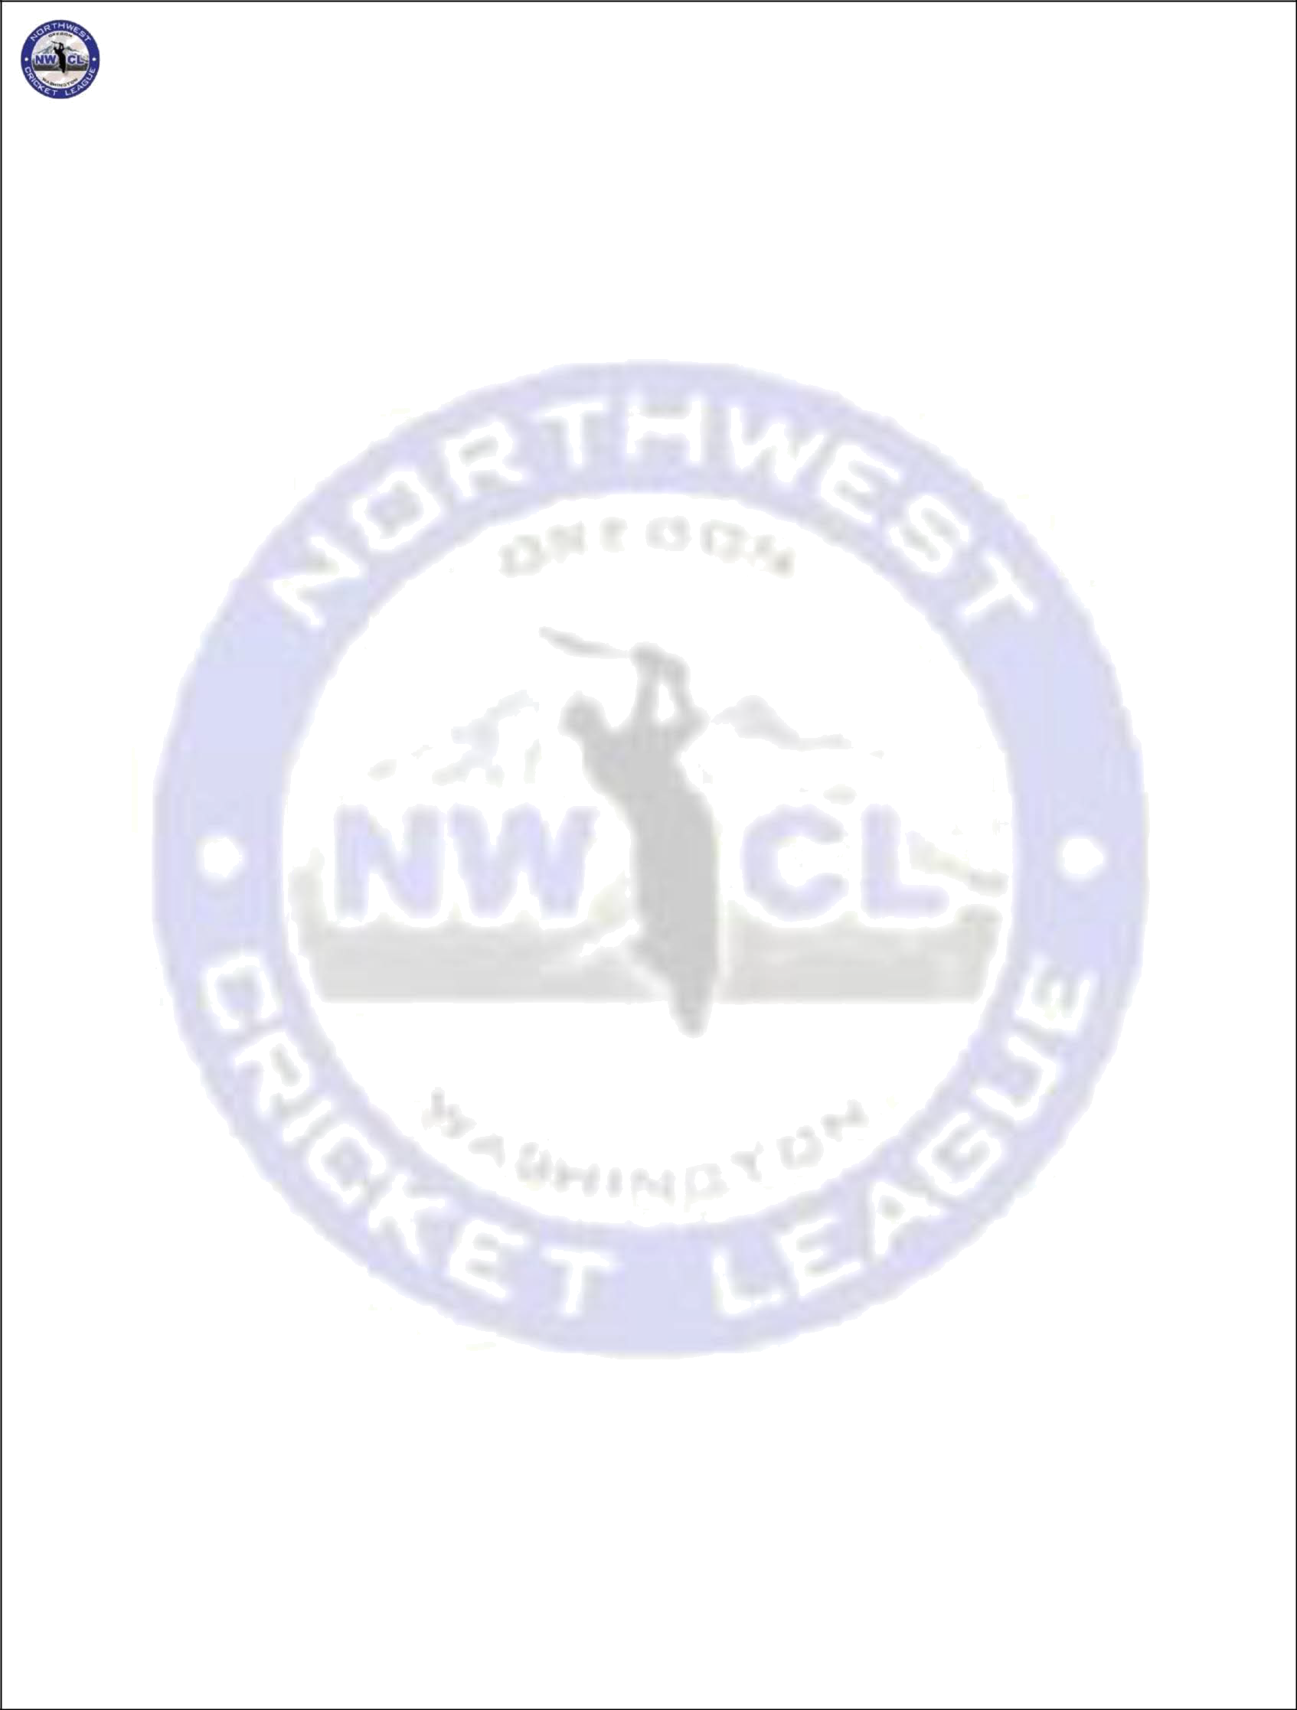
NORTHWEST CRICKET LEAGUE – PLAYING LAWS

NOTE: All fines must be paid within 2 weeks of the first violation. If the fine is not paid on time, the team will forfeit their next game.

Captains
  - Captain's Report: For each game, each Captain is encouraged to submit a Captain's Report to the Operations Manager using the form available on the NWCL website.
  - LACK OF PROPER EQUIPMENT (ALL DIVISIONS) Both teams must have the official match balls provided for their division. Also, they must have bats, pads and any equipment needed for play. If they are not ready to play at the scheduled start of play, the umpire will remove ‘batting’ overs of the offending team. (Rate: 1 over for every full 4 minutes) till a minimum of TWENTY overs cannot be batted by the offending team. HOME TEAM IS RESPONSIBLE FOR HOLDING THE MATCH, SO THEY MUST HAVE AT LEAST ALL THEIR EQUIPMENT TO MAKE THE GAME POSSIBLE. If properly installed Stumps, bails, boundary markers & standard score book are not provided BY THE HOME TEAM (FIRST TEAM NAME ON SCHEDULE) the umpires will keep reducing the batting innings of the offending 'home team '(Rate: 1 over for every full 4 minutes) till a minimum of TWENTY overs cannot be batted by the home team. In that event, they would forfeit the match to the other team. No NWCL regulated MATCH can commence without bails on the wickets, if Bails are missing HOME TEAM will be considered offending team and will penalized hourly over rate as mentioned above

Scoring
  - Dot ball scoring is the norm for NWCL matches. Dot ball scoring is defined as the recording of every ball received by each batsman, as well as every ball bowled by eachbowler.
  - First and Last names of all players shall be recorded in the score sheets with the Captain (*) and wicket-keeper (+) of each side identified.
  - Names of the Umpires and the team that won the toss.
  - Extras scored in each innings, separated by byes, leg byes, wides and no balls
  - Fall of wickets and Over # for each wicket that falls and the batsman the got out.
  - The names of players effecting a dismissal shall be recorded. This includes players taking a catch or affecting a run out dismissal.
  - Bowling Analysis for each bowler, which shall include Overs, Maidens, Runs, Wickets, Wides and no balls.
  - The score sheet for each game must be submitted electronically to the person handling the league statistics by 10PM PST of the first Tuesday following the game. If a club does not make
this deadline it shall incur the following penalties:

- 1st Violation: 10 points deduction + $100 fines
- 2nd Violation: 15 points deduction + $150 fines
- 3rd Violation: 20 points deduction + $200 fines
- 4th and Final Violation: Disciplinary action up to and including suspension from the
league.

NOTE: All fines must be paid within 2 weeks of the first violation. If the fine is not paid on time, the team will forfeit their next game.

Balls
  - Four-piece leather balls shall be used for all the games conducted by the NWCL.

  - The official ball of NWCL will be announced by the NWCL Management prior to the start of each season. Umpires and Captains should ensure that no other brands are used. Two One new ball shall be used at the start of each innings. However, if, during the game, the condition of the ball is Damaged, and the umpire sees the need to change the ball, then he is entitled to do so with a used ball that has to be provided by the bowling side. (Passed via email as special request on 4/8/2018 with 12 -3 majority)
page 5 of 12

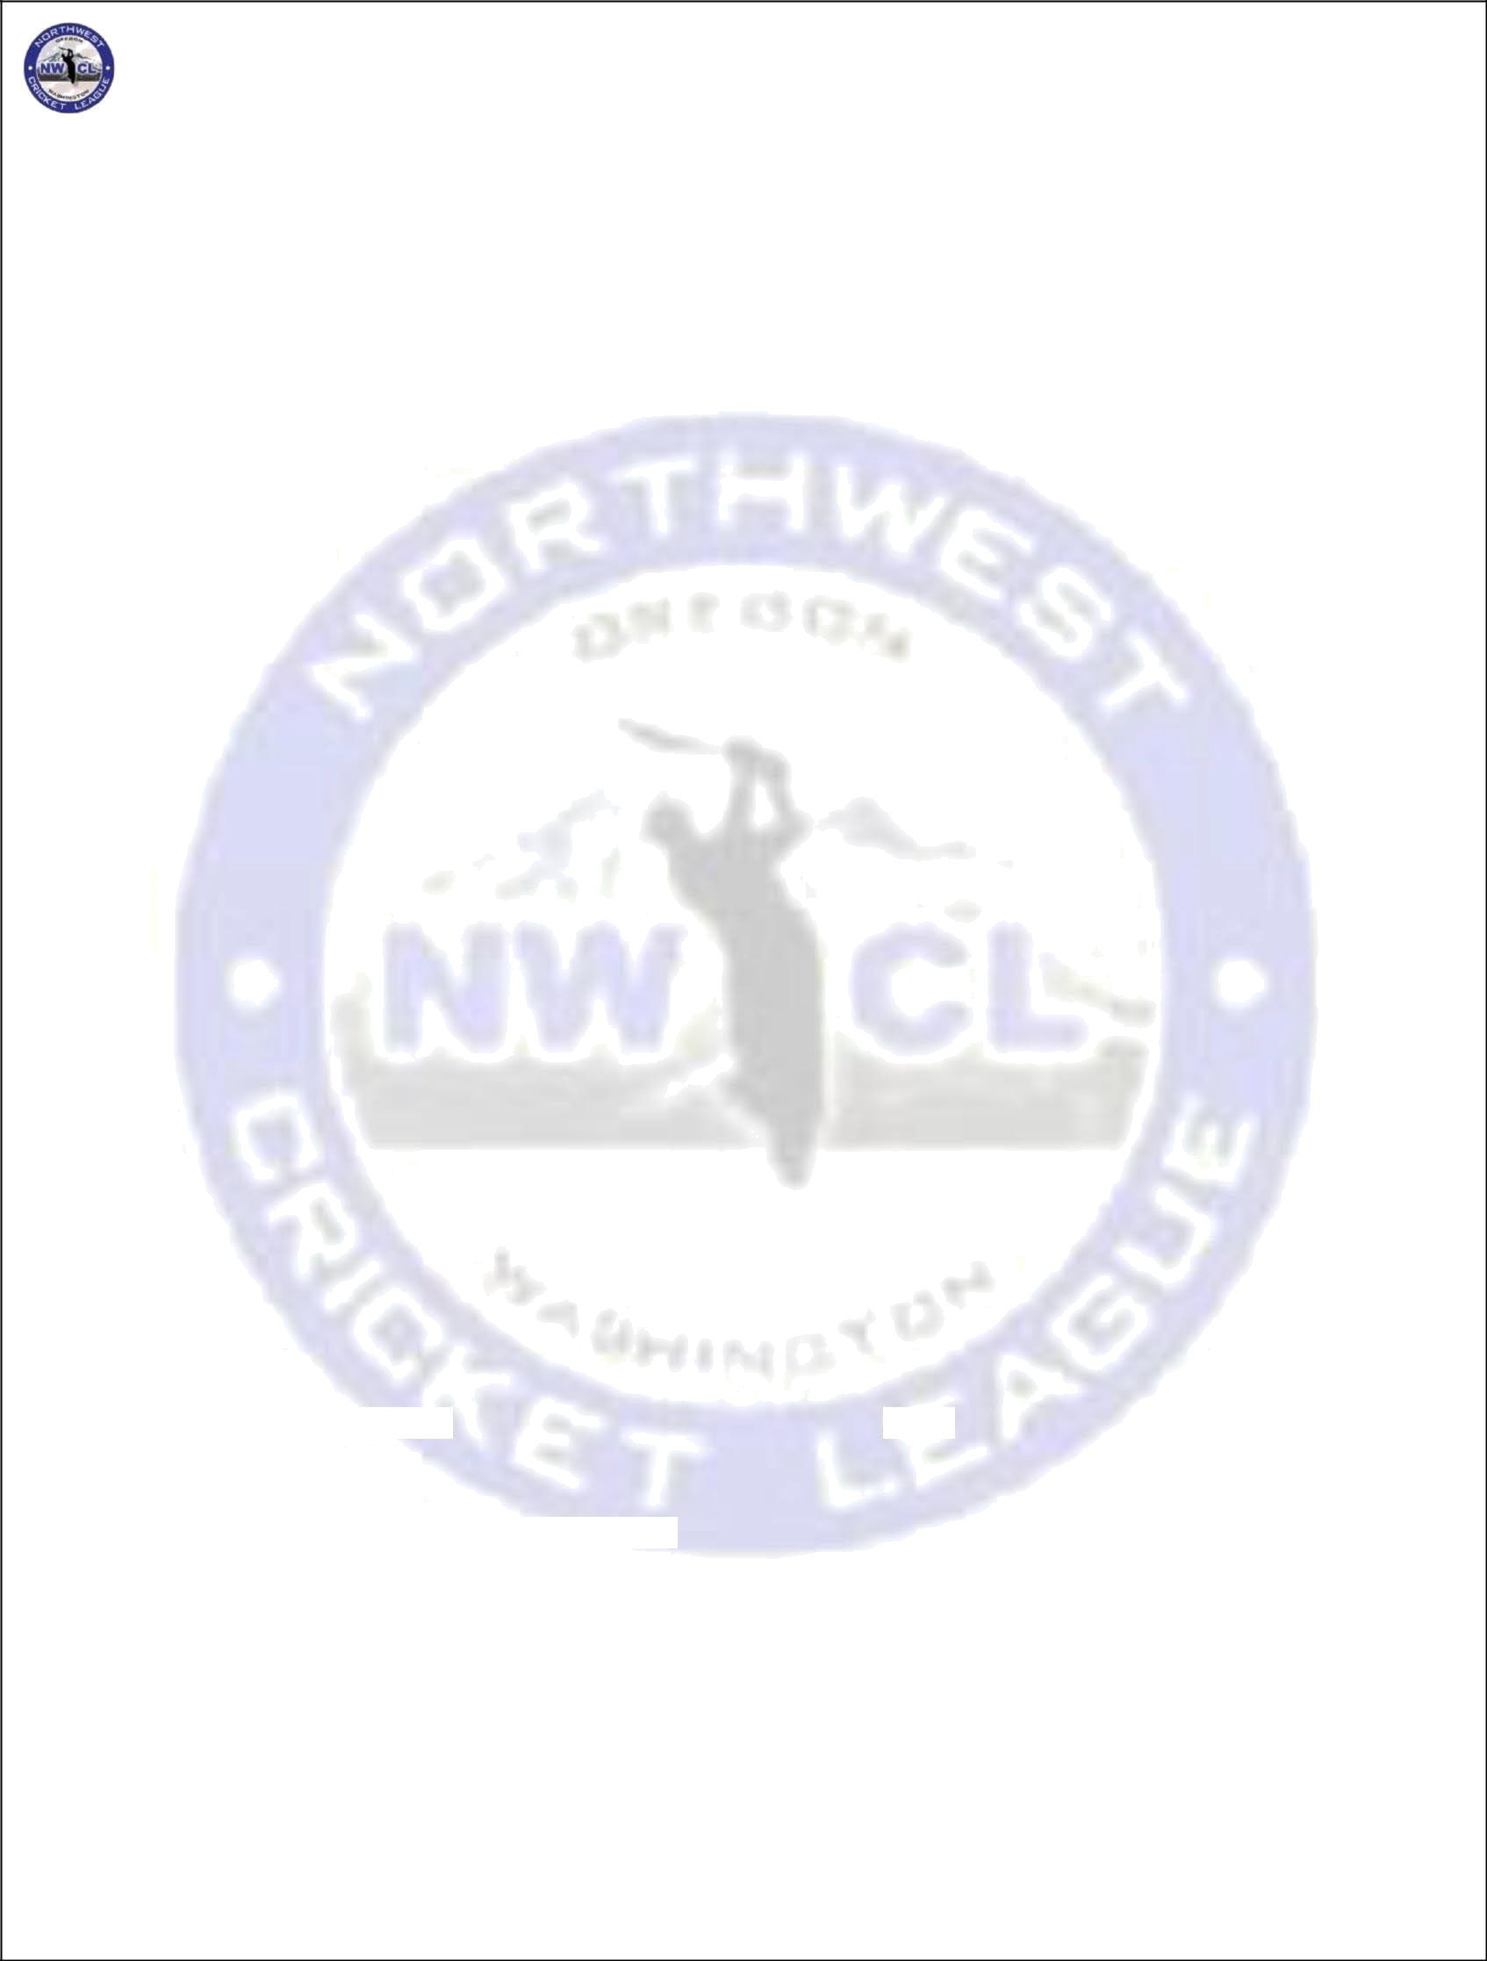
NORTHWEST CRICKET LEAGUE – PLAYING LAWS

Innings
  - A match shall be of one innings of each side.
  - Each innings will be of 40 overs.
  - A bowler can bowl a maximum of 8 overs. If there is a reduction in the number of overs before the match has started (as defined by Play' being called by the Umpire), the maximum number of overs bowled by a bowler will be calculated by dividing the number of overs to be bowled per innings by 5 and rounded up to the nearest whole number.
  - Innings length: 40 overs must be completed by 1st fielding team in 3 hrs. (1:30pm for a scheduled 10:30 am start). The umpires together, will give two or more warnings (many – if needed) to the fielding Captain for a slow over rate (Less than 14 overs per hour). If after above warnings, 40 overs have not been completed in 3 hrs. the umpires will deduct one over for every full four minutes over 3 hours from the fielding team’s innings at bat. (Example: At 1:30 pm, 3 overs & 4 balls are left. At 1:44 the innings is over. 1:44 pm = 14 min/4 = 3 overs. Ignore fraction). The fielding team will bat 37 overs, if there were no other unforeseen delays. If no other delays & 1st innings is still on at 1:34 = -1 over, 1:38 = -2 overs, 1:42 = -3 overs, 1:46 = -4 overs etc. Team fielding second will be fined $5 dollars for every 5 minutes delay of game.

Practice on the pitch
  - Teams shall be allowed to practice on the pitch up to 30 minutes before the toss.
  - No practice on the pitch shall be allowed once the toss has taken place (including between
innings).

ICC ODI rules Adopted by the NWCL

  - Law 24.2: Free Hit After a Foot-Fault No Ball:
The delivery following a no ball, called for a foot fault (Law 24.5), shall be a free hit for whichever batsman is facing it. If the delivery for the free hit is not a legitimate delivery (any kind of no ball or a wide ball) then the next delivery will become a free hit for whichever batsman is facing it. For any free hit, the striker can be dismissed only under the circumstances that apply for a no ball, even if the delivery for the free hit is called wide ball. Field changes are not permitted for free hit deliveries unless there is a change of striker (the provisions of Law 41.2 shall apply). The umpires will signal a free hit by (after the normal No Ball signal) extending one arm straight upwards and moving it in a circular
motion.

  - Restrictions on Placement of Fieldsmen
Law 41.5 Restrictions on the Placement of Fieldsmen:
- At the instant of delivery, there may not be more than 5 fieldsmen on the leg side. The MCC rule that no more than 2 players may field behind square leg at any one time, is still in effect.
- From over 33 (end of 32 overs) there can be 5 fielders outside the 30-yard circle.
(06/15/2016)
  - Power-play Field Restrictions:
For a 40-over innings, the Powerplay Overs shall apply for 8 overs per inning and shall be taken as follows:
- The first block of 8 overs (powerplay) shall be at the commencement of the innings. During the powerplay overs (first 8 overs in a 40 over game), only two fieldsmen shall be permitted outside this fielding restriction area (30 yards circle) at the instant of delivery.
- There is no longer a batting powerplay. (06/15/2016)
- No catching positions needed. During the initial block of Powerplay Overs (in an uninterrupted innings, the first 8), there is no requirement for a minimum of two stationary fieldsmen within 15 yards from the striker's end at the instant of delivery. (06/15/2016)
- During the non-powerplay overs, no more than 4 fieldsmen shall be permittedoutside the fielding restriction area (30-yard circle).
- Each block of Powerplay Overs must commence at the start of an over.
- In circumstances when the number of overs of the batting team is reduced, the number of
Page 6 of 12

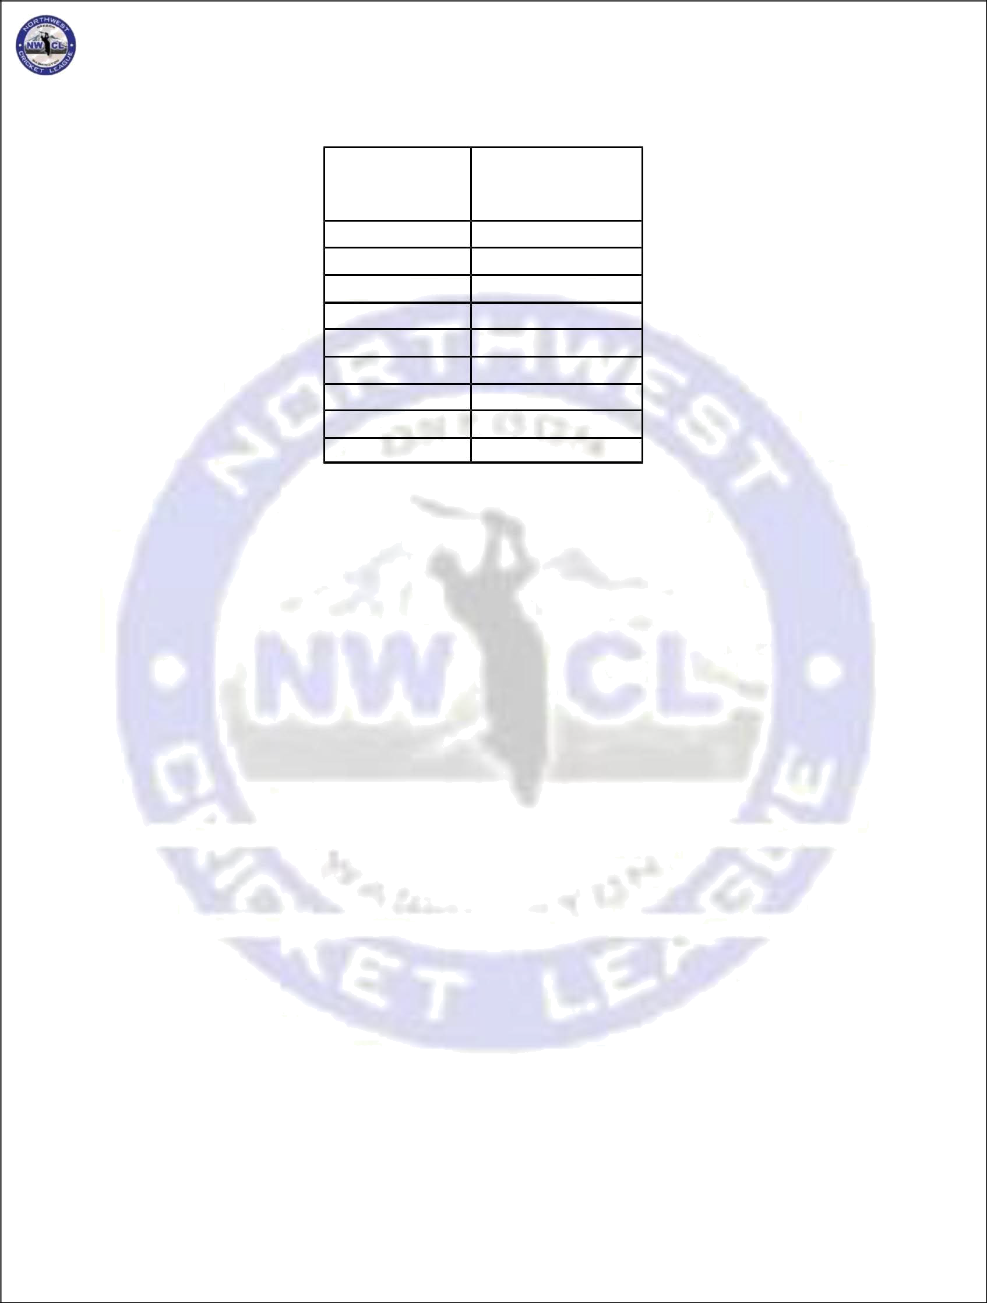
NORTHWEST CRICKET LEAGUE – PLAYING LAWS

Powerplay Overs shall be reduced in accordance with the table below. For the sake of clarity, it should be noted that the table shall apply to both the 1st and 2nd innings of the match.
Total
Innings  Duration | Powerplay  overs
20-21 | 4
22-23 | 5
24-26 | 5
27-28 | 6
29-31 | 6
32-33 | 7
34-36 | 7
36-38 | 8
39-40 | 8
If play is interrupted during the Powerplay overs, then on resumption, it is necessary to determine how any remaining Powerplay overs should be allocated. The total number of Powerplay overs for the innings
is derived from the table
above.

Start of Play
  - Unless decided otherwise by the Captains and the Umpire(s), all matches shall start at 10:30am. For games in which one of the participants is travelling to Seattle from more than 100 miles away, or vice versa, the start time shall be 11:00am.
  - If there are restrictions on the availability of a ground the Home Captain shall inform the Visiting Captain and Umpire(s) 4 days prior to the game.
  - The Captains should decide to be in contact with each other via telephone on the morning of the match, lest the start of the match is affected by weather or travel delays. The captain of the home club shall be accessible via phone or otherwise within 60 minutes of the scheduled starting time of the match.
  - If the visiting club cannot make it to the ground 15 minutes before the scheduled start of play, then the home club should be informed of this at least 30 minutes before the start of play. Failure to do this will result in the visiting club being penalized one over in their innings for every 4 minutes (or part thereof) of delay in the start of the match.
  - This requirement does not apply for unforeseen circumstances, such as accidents and major traffic jams, where it is not possible to get to a phone before the required deadline.
  - If the match does not start on time for reasons of ground and/or pitch not being prepared, or the home club members not being present on the ground, then the home club will be penalized one over in their innings for every 4 minutes (or part thereof) of delay in the start of thematch.
  - If a match starts after 1:00 pm in the months from May to August and 12:30 pm in the months of September and October, due to reported travel delays for the visiting club or due to weather interference or due to unforeseen circumstances, one over would be deducted from each innings for every delay of 8 minutes or part thereof.

Intervals
  - Lunch break: There shall be an interval of 30 minutes between each innings. This interval should

Page 7 of 12

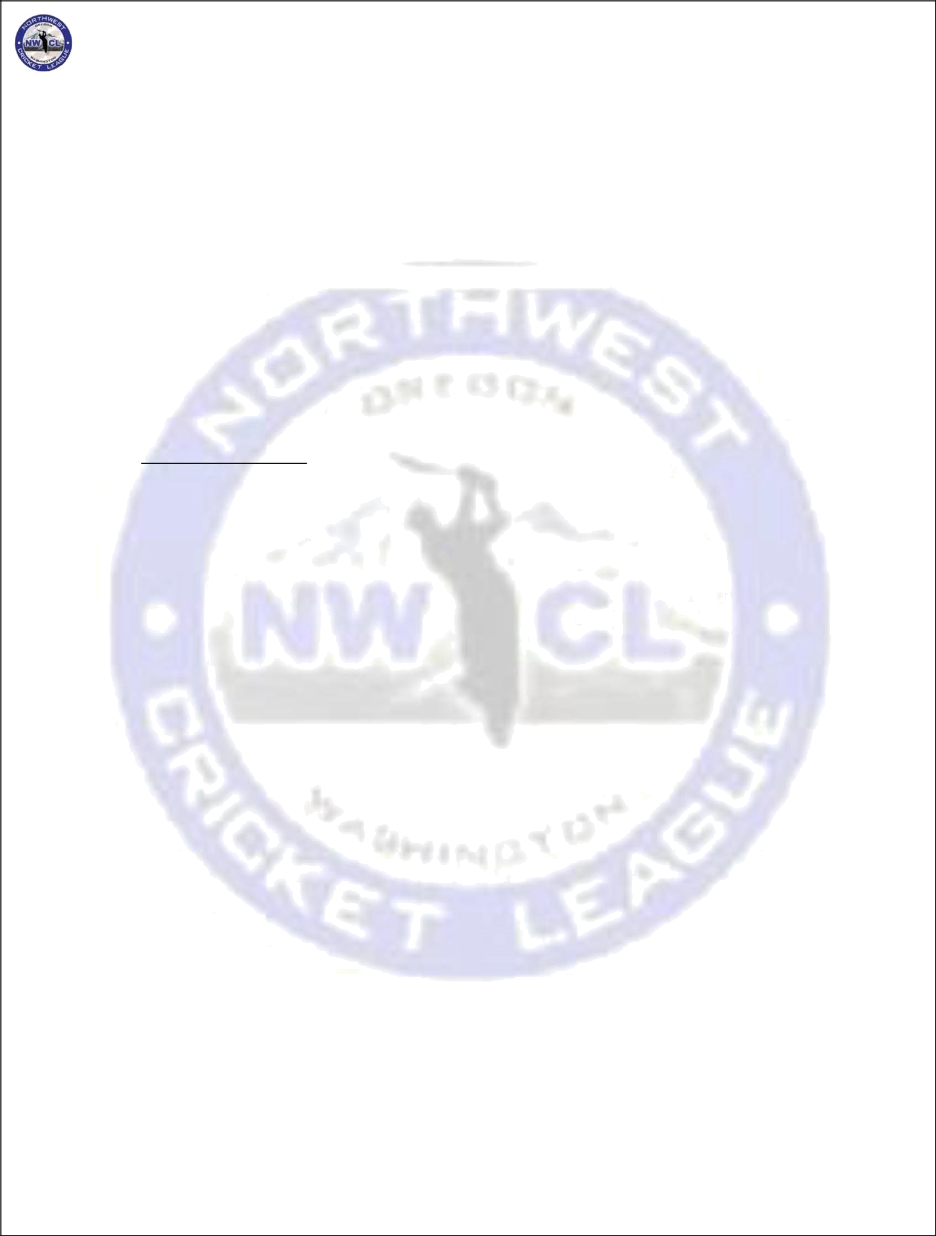
NORTHWEST CRICKET LEAGUE – PLAYING LAWS

be followed for all NWCL games, regardless if the home team serves lunch between intervals or not.

  - Drinks break: One break of 10 minutes shall be taken after the completion of the 20th over in each innings. The Captains have an option of deciding to take two breaks of 5 minutes each after the 15th and 30th over of the innings, provided this decision is made before the toss for innings and the umpires are informed of it before the start of play.

  - Innings length: Each team must complete its bowling quota of 40 overs in 3 hours max (including the time for drinks breaks). If the side bowling first does not complete its 40 overs in the 3 -hour time limit, the Umpires will note the number of overs completed at 3 hours. The bowling side will complete the 40 overs but will only be permitted to bat the number of overs that it bowled within
the 3-hour limit. If the team bowling second, bowls at a slower rate for no external reason (like

wet conditions etc.) it will be subject to a fine of $5.00 for every 4 minutes beyond the 3-hour time limit.
  - Umpire's responsibility: The umpires are solely responsible for determining the speed of play and for enforcing this rule. They are also responsible for adjusting the 3-hour limit when interruptions, beyond the bowling sides control (e.g. injury), cause a stoppage in play.

Interruptions of play
- If there is an interruption of play, due to weather or otherwise, overs will be deducted from one or more innings based on the following calculations:
  - If the interruption is less than the number of minutes between the time of start of play and 1 pm for the months from May to August, and 12:30 pm for the months of September and October, then no overs will be deducted for the interruption.
If the interruption does not meet the requirement in (i) and the first innings is in progress,
then one over will be deducted from the innings in progress as well as the next innings
for every 8 minutes lost or part thereof. If the second innings is in progress s then
one
over will be deducted for every 4 minutes lost or part thereof. The target shall be revised
to the product of the overall scoring rate of the first innings and the number of overs in

- Rain curtailed games are treated as completed so long as at least 20 overs have been bowled in each
innings.

Result
- The winner of each match gets 20 points.
- The loser of each match can get a maximum of 10 bonus points as follows; Batting Bonus Points: If team chasing loses
1 point if team total of completed innings is more than 50% of target 2 points if team total of completed innings is more than 60% of target 3 points if team total of completed innings is more than 70% of target 4 points if team total of completed innings is more than 80% of target
Page 8 of 12

NORTHWEST CRICKET LEAGUE – PLAYING LAWS

5 points if team total of completed innings is more than 90% of target

Batting Bonus Points: If the team defending loses:
1 point when target is conceded after 20 overs 2 point when target is conceded after 24 overs 3 point when target is conceded after 28 overs 4 point when target is conceded after 32 overs 5 point when target is conceded after 36 overs

Bowling bonus Points:

1 point if 2 wickets have been taken 2 points if 4 wickets have been taken 3 points if 6 wickets have been taken 4 points if 8 wickets have been taken
5 points if 10 wickets have been taken in the opponent's completed innings

In c as e of a tie, as defined by these scores being level after both teams ' innings havebeen c completed, each team gets 12 points (Pas s ed at BOD on 05/15/2014)
am to which a match is conceded wil
- A team conceding a match will be deducted 15 points. The te

l be

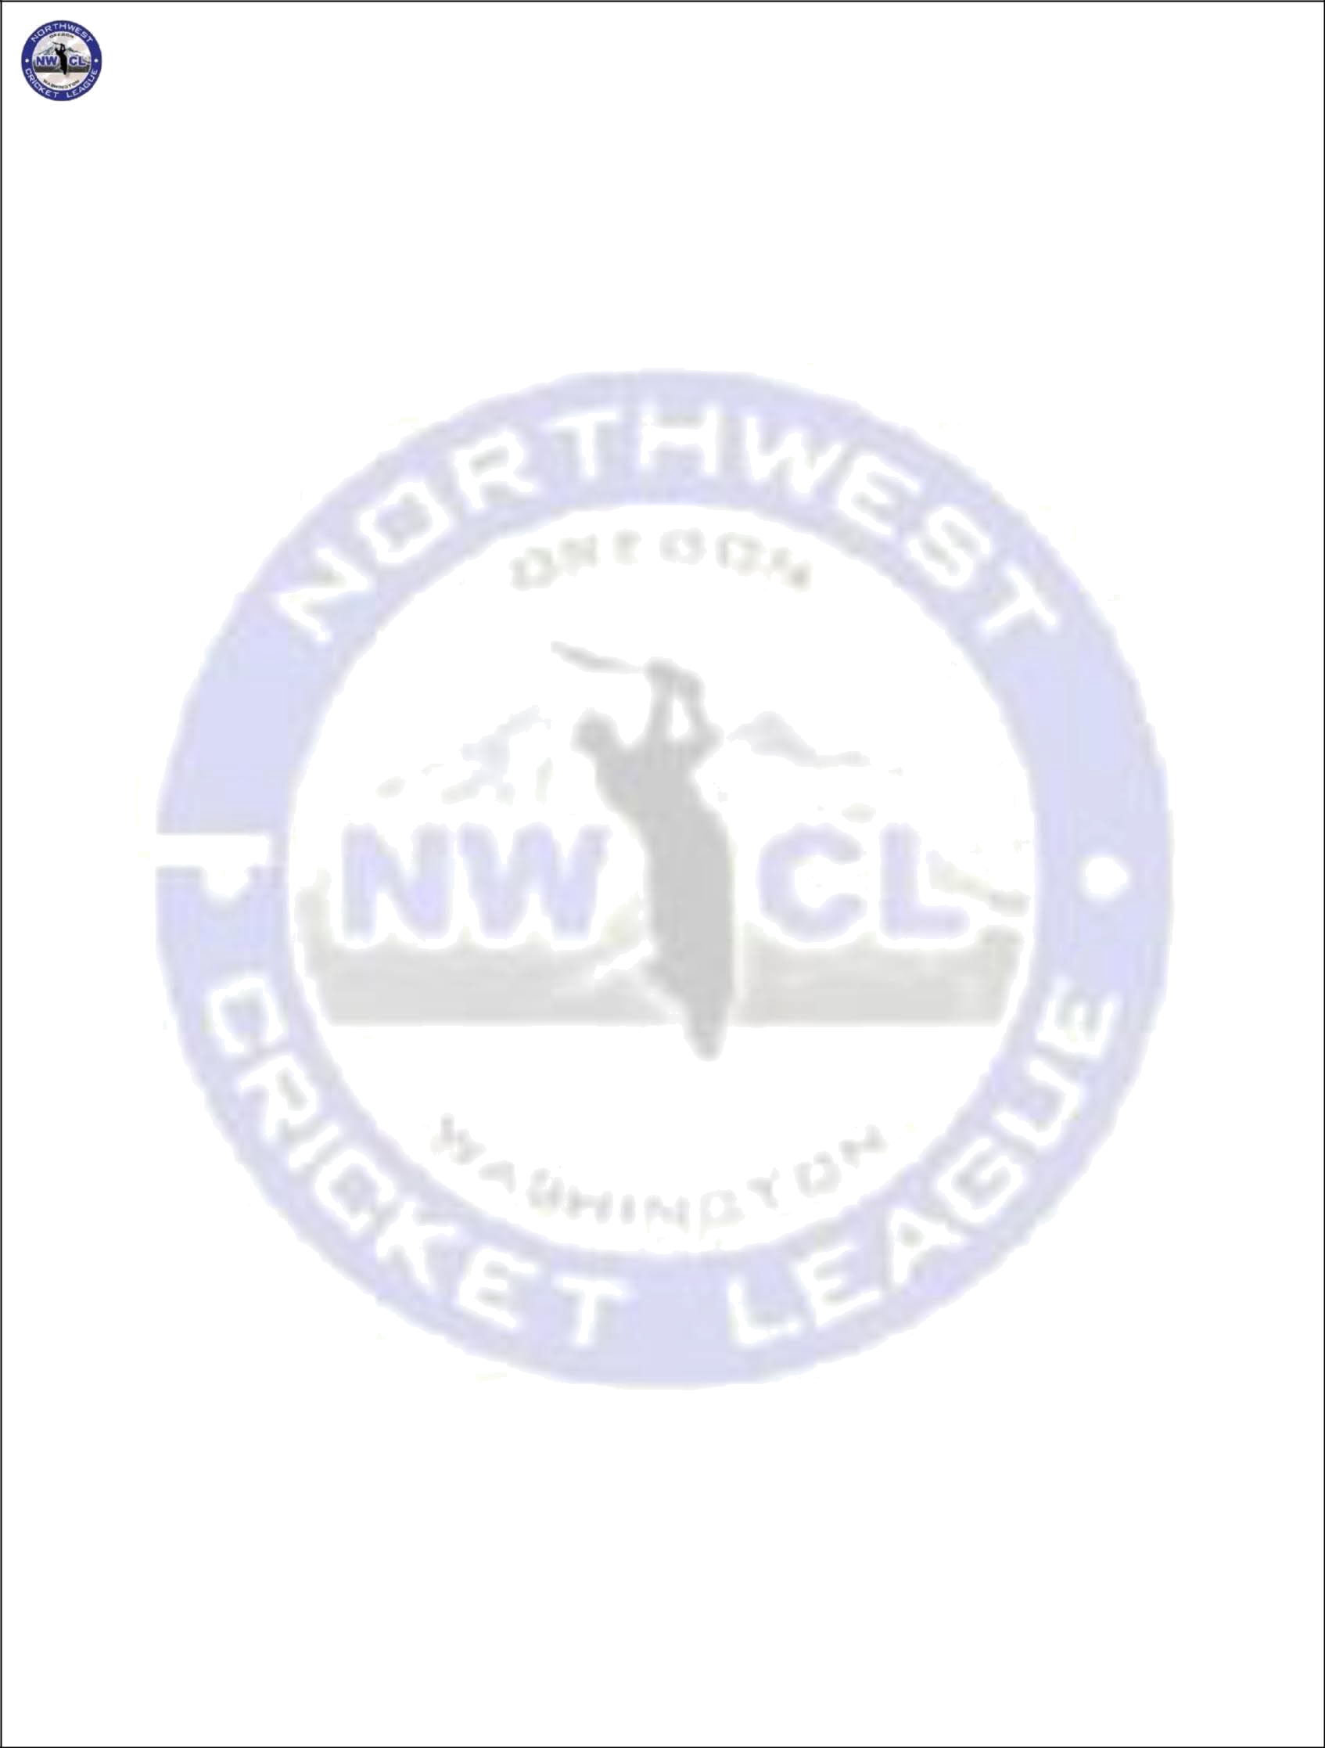
considered the winner of the match and will be awarded 20 points. The team conceding the game will be fined $200 for conceding the game.

- If, due to weather interruptions, the two innings are of un-equal overs, then the result of the match will be decided by the scoring rate per over, with the side having the larger scoring rate being declared the winning side. In such a scenario, the bonus points shall be prorated to 40 overs, that is, if both innings are of equal length in terms of overs, the bonus points shall be calculated by scaling the bonus points obtained by the ratio of {40/actual overs per inning} and rounding off (up or down) to the nearest whole number. If the innings are of different number of overs, bonus points for batting and for bowling are considered separately: each is scaled up to a 40 overs scenario (without rounding off), then the sum is rounded off (up or down) to the nearest whole number.
- No points can be gained for forfeited games if both teams are from the same club. (Passed at Extraordinary BOD on March 8, 2014)
- In case of Tie in Playoffs: In case of tie in playoffs a super over is mandatory regardless of regular season standing, team left the ground without playing super over will be considered as forfeiting the playoff game. Super Over will commence 10 minutes after the main match. Each team bats one over under the same restrictions as for the final over in a pool match.
- The team batting second in the main match will bat first in the Super Over.
- Each side has three nominated batsmen, meaning that the loss of two wickets ends the Super Over.
- In the event of the scores being level in the Super Over, the first satisfied of the following criteria will determine the winner:
- If the regular match utilized the Duckworth–Lewis method, criterion 4 immediately applies.
- The team with the greatest number of boundaries combined from the main match and the Super Over is the winner.
- The team with the greatest number of boundaries from the main match (that is, not including the Super Over) is the winner.
- A count-back from the final ball of the Super Over shall be conducted. The team with the higher scoring delivery is the winner. Runs scored from illegal deliveries count towards the total for the following legal delivery.
Page 9 of 12

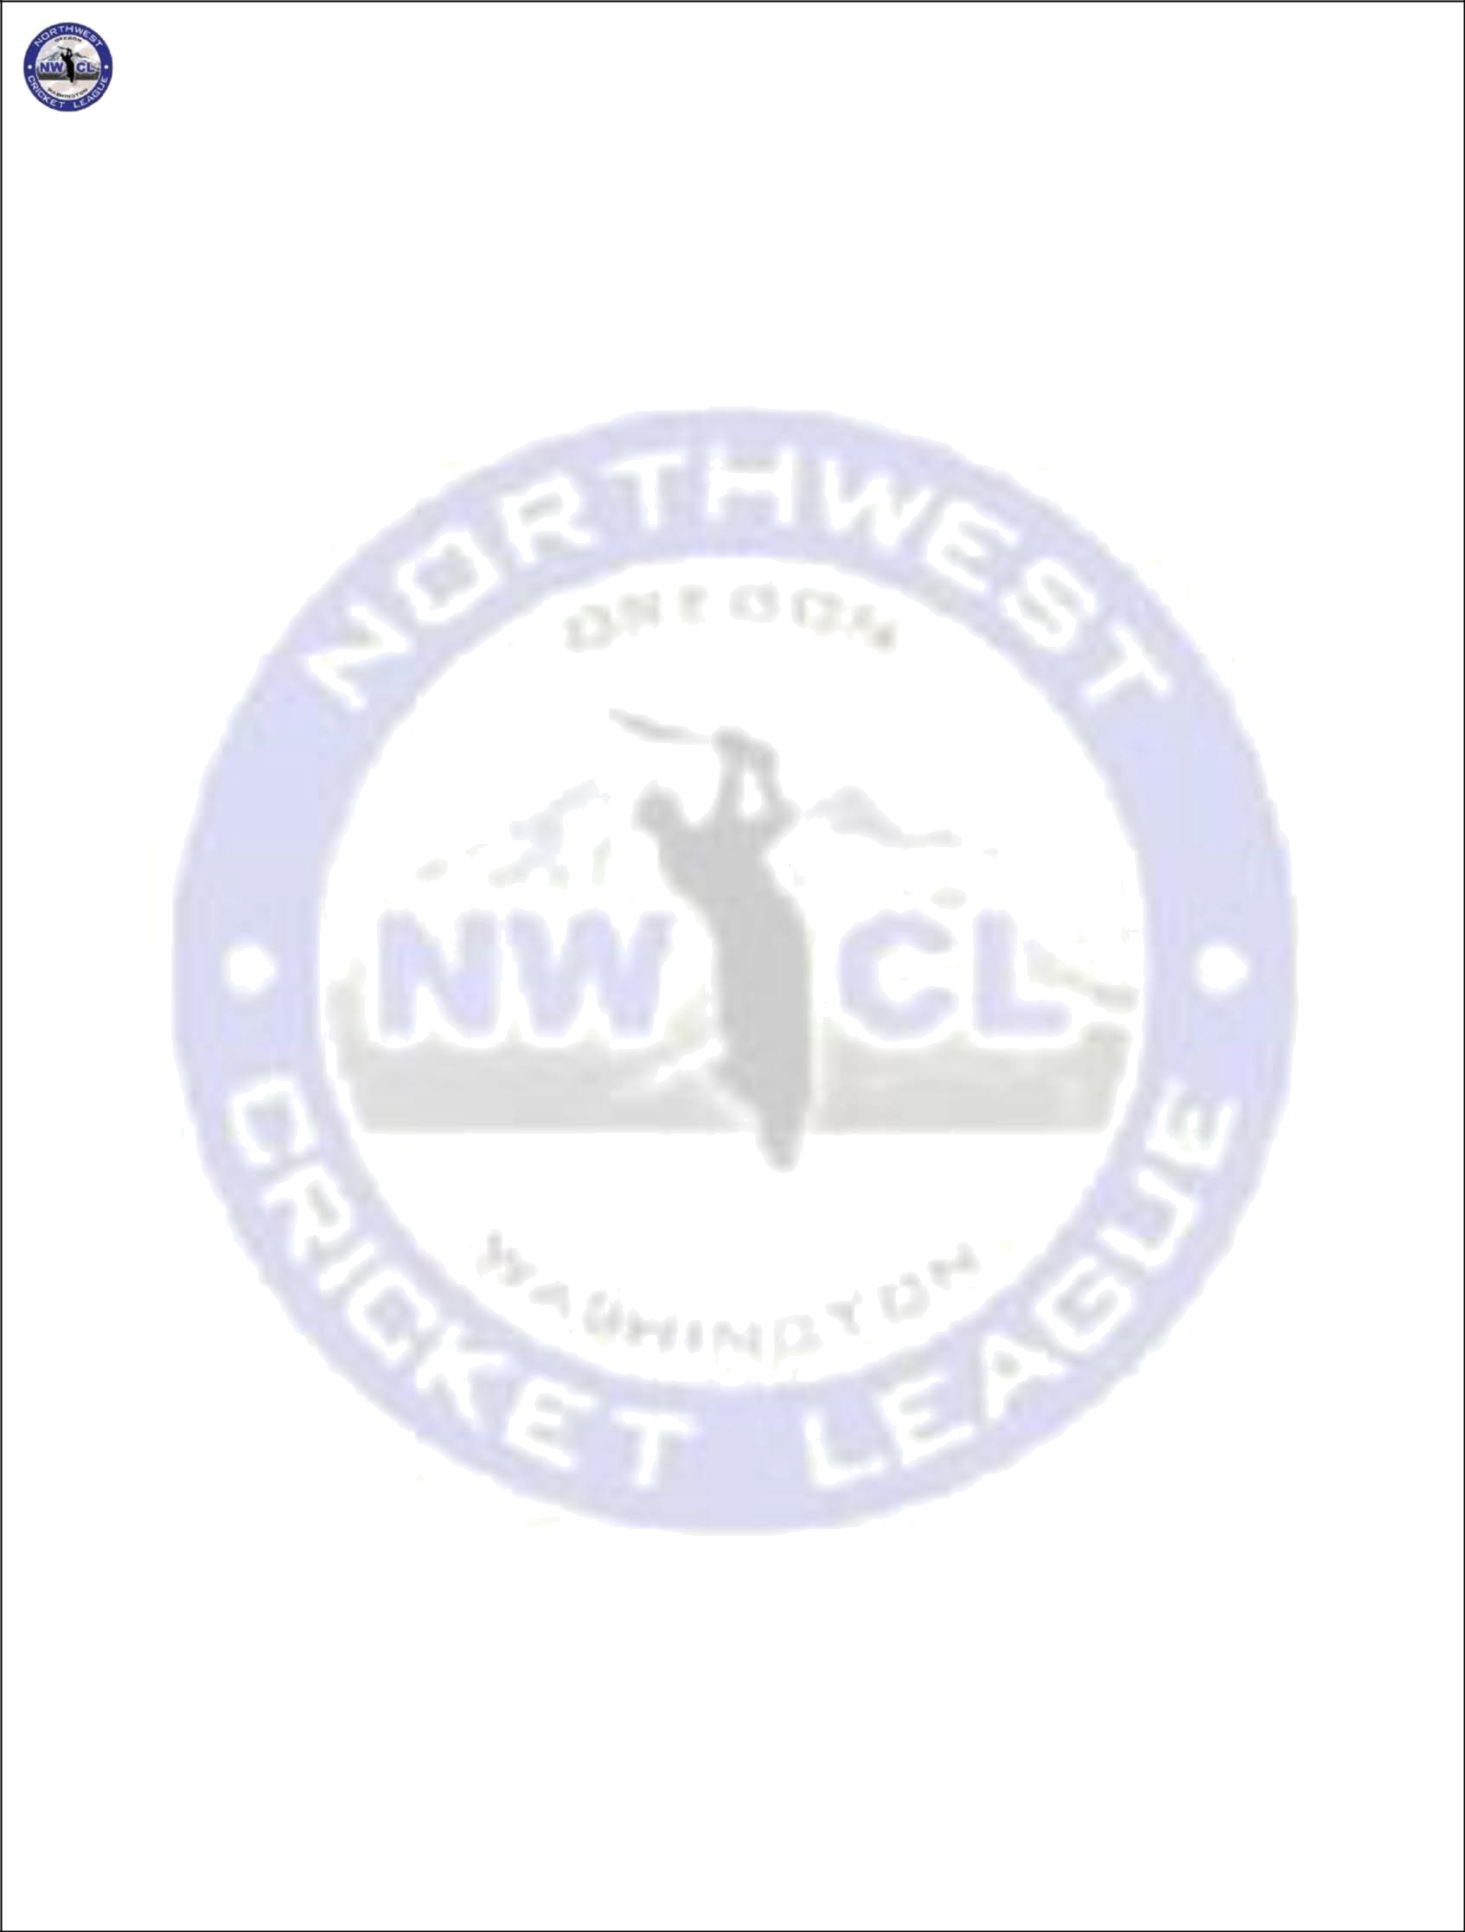
NORTHWEST CRICKET LEAGUE – PLAYING LAWS

Wide and No-Ball
  - Leg Side Wide Ball: If a ball pitches outside the leg stump and passes down the leg side of the striker without touching any part of the person or equipment of the striker, the umpire shall call and signal 'wide ball' (even if the striker tries to play the ball).
  - Off Side Wide Ball: If a ball, not being a no ball, passes outside the "wide marker line" (29.5"from the outer stump on each side) or crosses this line during its flight after having pitched outside the off- stump, the umpire shall call and signal wide ball. Whether the batsman attempts to play the ball or brings it within reach is immaterial.
  - A ball shall be considered a "No ball" if, after pitching, it would have passed over the batsman's head if he was standing straight in the crease.
  - A ball shall be considered a "No Ball" if the ball would have passed, on the full, above waist height of the striker standing upright at the crease.
  - A ball that would have passed above the shoulder, but below the head, of the batsman standing upright in the crease is NOT a "No Ball".
  - If a ball bounces more than twice before it reaches the popping crease shall be considered a No-
Ball
  - No Ball. –Penalty for either “Throwing and Chucking “the Ball or Underarm bowling (ball delivered from below shoulder level), main umpire shall call & signal no ball & the bowler will receive a first & final warning. If repeated, the bowler will be suspended from bowling for the innings. Fair delivery: the arm – will follow MCC Law 21.2. All other No ball regulations are per MCC Law & ICC PCs. Main Umpire has the sole discretion of deciding if bowler is bending the arm enough to be considered chucking

Protective Equipment
All protective equipment usually worn under clothing (thigh pad, box, chest guard etc.) must be worn under clothing and not visible to the umpires. If a batsman wears such equipment in view, the umpires must instruct him to either wear it under his clothing or remove it altogether. Failure to concede to this request shall be treated, as a mark of indiscipline and the umpire must report the player to the league. No spiked footwear is permitted on any artificial pitch or a natural one that has a covering. An offending player’s club will be billed for damages by the League upon immediate report. An offending bowler will be IMMEDIATELY suspended from bowling till he has appropriate footwear.

The wicket is down
- When Spring-back Stumps are used, it is not possible to strike the stumps out of the ground as is required by Law when both bails are off. In such a case, the decision as to when a stump is struck out of the ground is one for the umpires to decide on the facts before them.
- When Spring-back Stumps are used, the bails are often dislodged when the ball hits the cast iron support base of the stumps. If this is so, the bails will not be considered dislodged and the wicket is not down for the purposes of this Law.

Criteria for Cancellation of Matches due to Weather
a)
For matches between teams in the same Metropolitan area, the Captains (or their representatives) from the two teams shall inspect the ground the day before the match. If, based
on present field conditions and weather forecasts, a decision is reached at that time to abandon the match, then the Secretary shall be informed of it. If the Captains do not agree on a decision at that time to abandon the match, then the decision will be postponed to the morning of the match, one hour before its scheduled start. If a decision is reached at that time to abandon the match, then that decision is final, and the Secretary should be informed of it promptly. If, at that time the Captains' still do not agree and there are no neutral umpires present, then the Home Captain's
decision is final. If neutral umpires are present, then they shall decide and inform the

more),
Captains.
For matches between teams from different Metropolitan areas (i.e., matches entailing travel of 50 miles or
Page 10 of 12

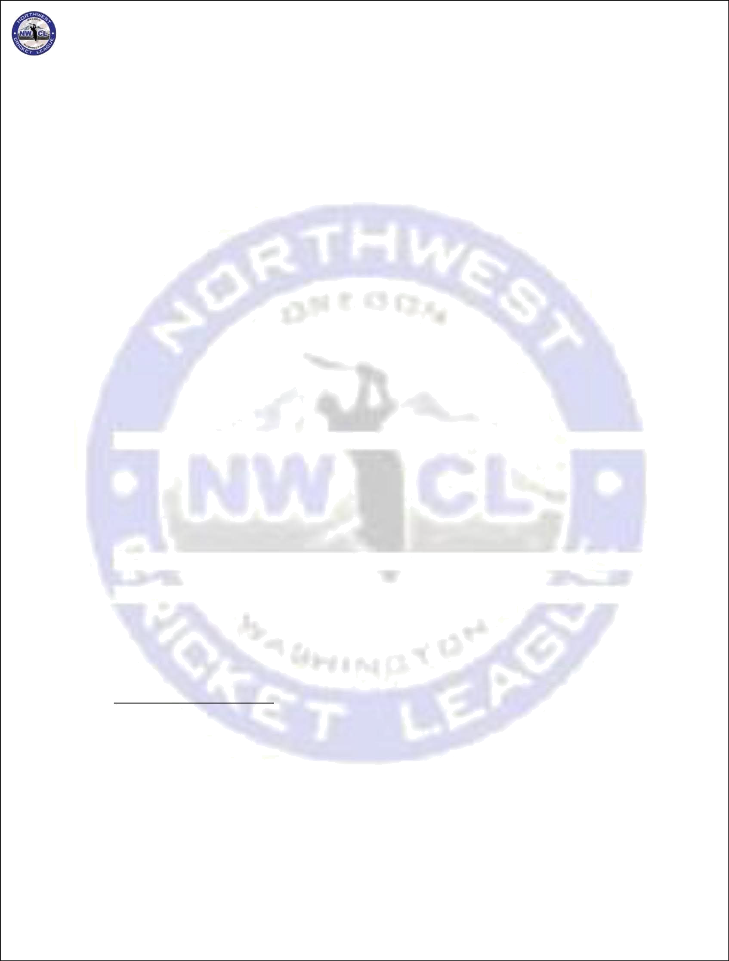
NORTHWEST CRICKET LEAGUE – PLAYING LAWS

the Home Captain (or his representative) shall inspect the field on the day prior to the day of the match, decide based on present field conditions and weather forecasts and inform the Opposing Captain of his decision by 6 pm on that day. If the decision is to abandon the match, the Secretary should be informed promptly. If the match is not abandoned at that time, the Home Captain (or his representative) shall inspect the field in the morning of the match and if he decides to abandon the match, he shall inform the Opposing Captain immediately. The Secretary shall also be informed promptly.
- About matches for which WSU is a participating side, the Home Captain shall decide 24 hours before the start of the match based on present field conditions and weather forecasts and inform the Opposing Captain of this decision. This decision is Final and shall be communicated promptly to the Secretary by the Home captain.
- Per the Laws, after the toss of innings, the umpires are the sole judges of the weather and other
conditions, and the decision to abandon a match rests with the umpires. If neutral or dedicated umpires are not present, then the Captains shall be the sole judges of the conditions. If they
cannot agree then the status quo will continue.

Determination of the Standings in the league table
The Teams shall be ranked in the League Table according to average points per completed match (to the second decimal place).

Interpretations
These are a collection of some clarifications regarding various situations that may not be clear in the Laws. It will be beneficial to move these to formal sections above eventually.
- Player batting without fielding at all: A player can bat if he has not fielded under the following
circumstances. The lists of players are exchanged, and the toss is made, and then a player in
the list for one of the teams falls ill (genuinely as determined by the umpire). The Laws allow a
substitute to field for him. If his turn comes to bat and he is then capable of batting because he is
feeling better he should be allowed to bat per the laws. Of course, all this assumes there is no
duplicity going on and the player is ill and then gets better as the match progresses.

- Water breaks: a batsman may upon approval of the umpire get a drink between overs. This should be done without wasting any extra time.
- Player who arrives late and wants to bowl: As long as he is on the list the players may join at any later stage ... also they can come in and if the team is bowling, they can start bowling right away (that is they do not have to be on the field for the number of overs they are late before being allowed to bowl).
- If a player (who is on the list) shows up after the completion of first innings (first 40 overs), he shall not be allowed to bowl or bat in the second innings.
- Fielder/ Bowler taking break: If a fielder takes a break during a match i.e. goes out of the field, he will wait same number of overs he stays out of the field before he can bowl.

Scheduling
- Double Round Robin format will be applied to determine the number of games. Number of games played is dependent on the number of teams in that division. NWCL Management discretion, to increase number of games more than the double round robin requirements, based on scheduling and ground availability logistics. (Passed at Extra-ordinary BOD on 03/08/2014)

- For clubs with more than 1 team in a division, all intra-club games should be scheduled within the 1st half of the season. (Passed at Extra-ordinary BOD on 03/08/2014).
- Given the increased teams in the league, it’s not feasible for to schedule a bye-day for all the teams. No request for bye weeks will be entertained. (passed at Extra BOD on 11/19/2016
Page 11 of 12

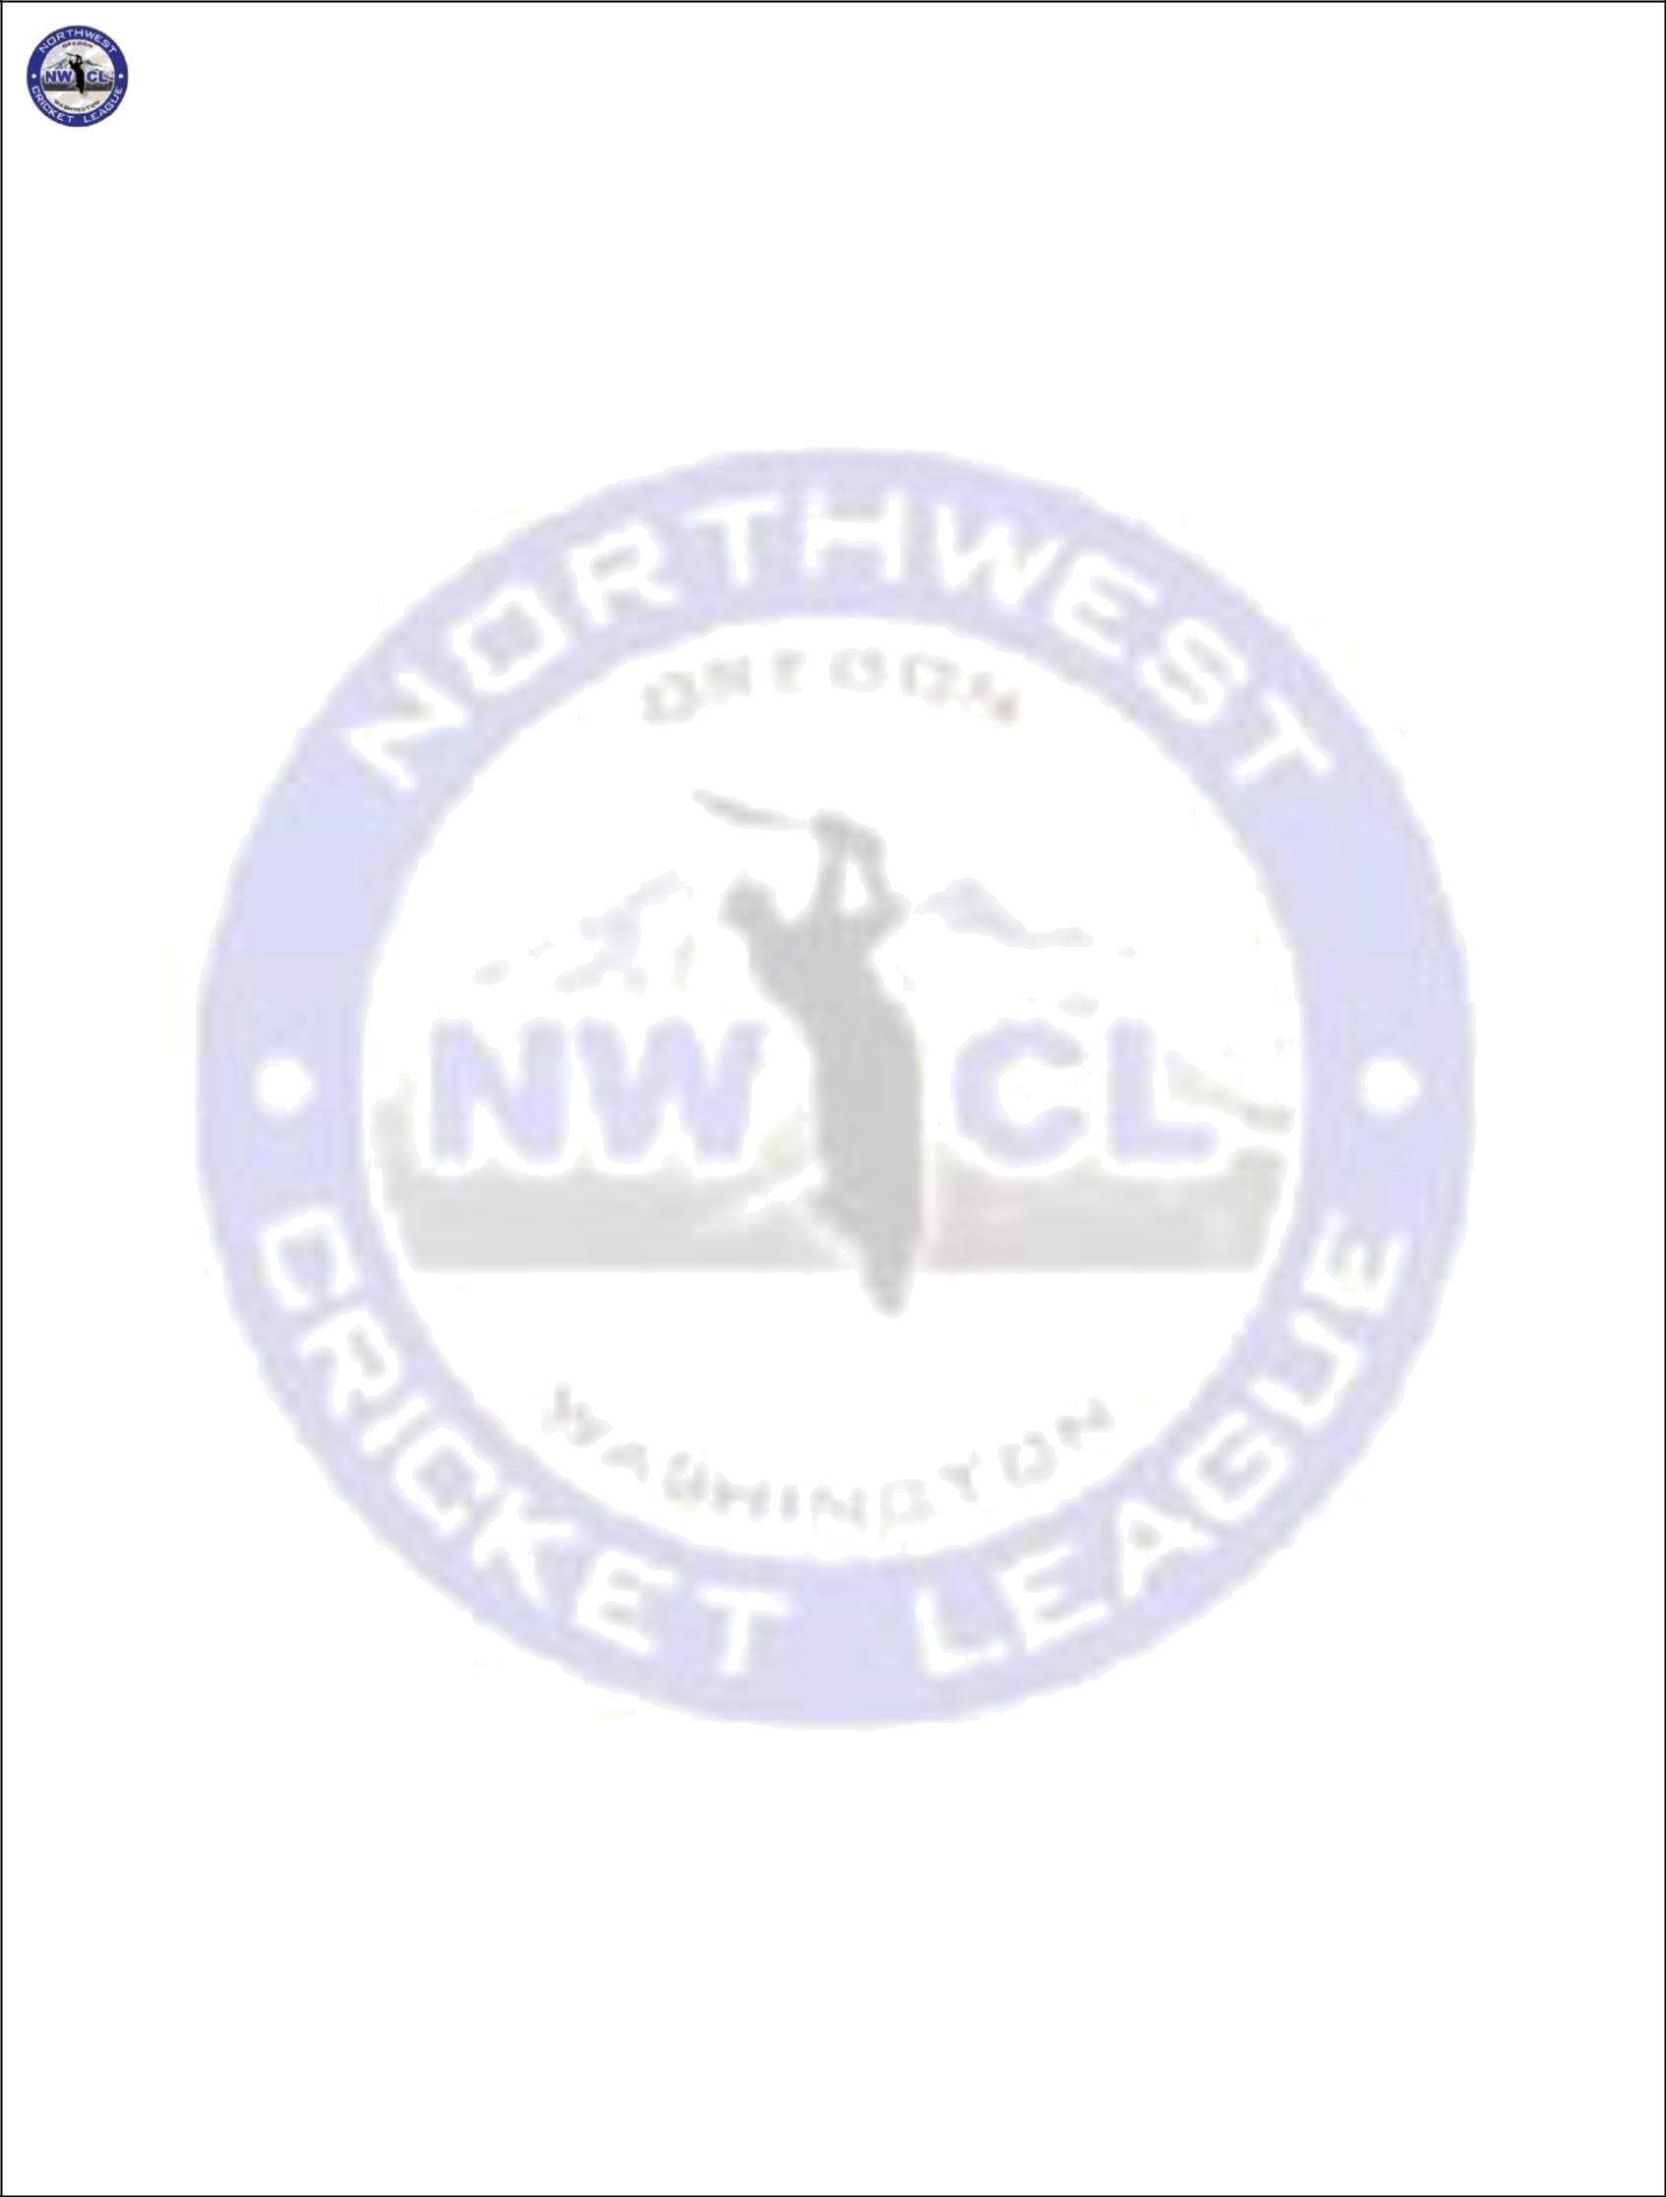
NORTHWEST CRICKET LEAGUE – PLAYING LAWS

- PLAYOFFS and Reserve Day: (Both i and ii passed at Extra-ordinary BOD on 11/19/2016)

  - If the finals are abandoned due to rain, then the trophy will be shared. If the semifinals are abandoned, then, the higher seeded team goes into the final.

  - Playoff for the premier (40 overs) league should be sponsored by NWCL and individual team should not be responsible for paying for the field. Currently it seems like individual team is being penalized economically for performing well during the season. The higher seeded team will be the home team and can pick the ground of their choice, it’s the higher seeded team’s responsibility to procure the ground, but, the management pays for it.

- Local Parks Management
1) (If reported by a Club/City Park manager or any official or member of the public, the NWCL management committee will assess penalties to Clubs whose teams used another clubs ground and do not put equipment away per Club/City rules, or do not pick up garbage at any field after a match

- INJURIES:
1) Any player with a bleeding injury must go off the field to be treated. The injured player shall not return to play until bleeding has been stopped by secure bandage or other appropriate means.

- Mankad
1) MCC Law 41.16 Non-striker leaving early: The bowler can try running out the non-striker by throwing/hitting the ball to his stumps during run up or delivery up to the point where he would normally deliver/release the ball. Even if by accident, the bowler’s hand/arm holding the ball breaks the bowler’s wicket during the specified time above, & the non-striker is out of his ground, he will be dismissed as Run out. 41.16.2 If the ball is not delivered and there is an appeal, the umpire shall make his/her decision on the Run out. If it is not out, he/she shall call and signal Dead ball as soon as possible. The ball shall not count as one in the over.

- Player Movement with Clubs and Teams
- Player movements are not allowed with in the Club after player has played one game for a team, no exceptions. Team and Club will be penalized for this, fines, forfeiture of game.
- Player Club Movements are allowed till May 31st for 2019 40 over season, with the release letter from original club. This date varies from season to season depending on start of the season. Team and Club will be penalized for this, fines ,forfeiture of game

Page 12 of 12

